

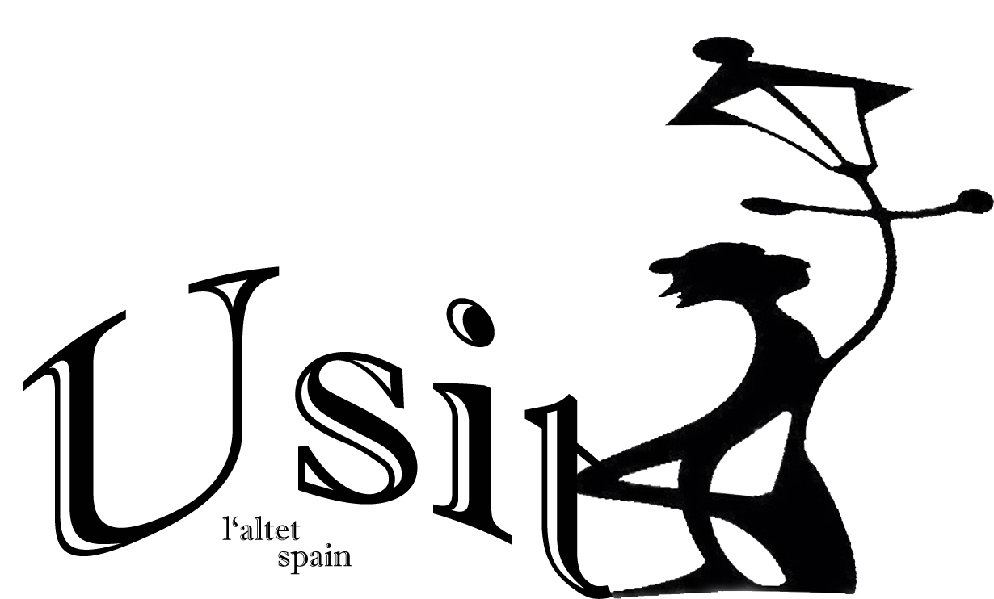
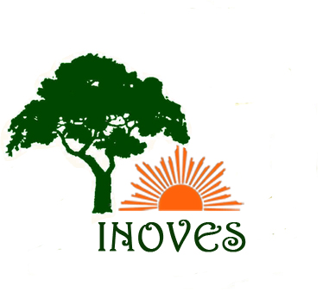

PROGRAM of “INOVES” project meeting in SPAIN
25th-28th of April, 2014

Host organisation :Asociation Usit ,Elche, Spain
 | 25/4 | 26/4 | 27/4 | 28/4
9-13 | Arrival | 8,45-8,50:Presentation of the project program and of the participants  8-50-11,00 Workshop : "Ecological and efficient use the resources and incidence of utilization of resources for ecosystems ; green technologies” | 9,00-11,30: Continuation of the presentation of activities developed by partner institutions from the precedent meeting until 24 April 2014.Presenting the site of the project by Polish partner .  -Report about initial evaluation of the project made by partner institutions.  . | Departure
9-13 | Arrival | 11,00-13,30 :Technical Visit to ASPE  Purifying plant and sewage recycling.  (wastewater as agricultural fertilizer) | -Share information, best practice and talk about activities in local / international level of the project.  Establish tasks ,deadlines and responsibilities for next period of the project. Diplomas | Departure
13:30 |  | LUNCH | LUNCH
15 -19 | Arrival | 15,30-17,30:Visit PACO RUBIO Bio and Eco farm and land | 15,30 -17,00  Elche Touristic Visit (Free)  Optional Guide | Departure
15 -19 | Arrival | 17,30-19,30:Presentation of activities developed by partner institutions from the precedent meeting until 24 April 2014 | 17,00-19,00  Elche Touristic Visit (Free)  Optional Guide | Departure
19:30 |  | DINNER | Evaluation  DINNER
 |  | Wine tasting (Optional) | Evaluation  DINNER

usit08@gmail.com // 649686721 // www.usit08.com

