1. Workshop: Ecological and efficient use of the resources and incidence of utilization of resources for ecosystems; green technologies.

1.1 Organization of the workshop: structure and aim

The organization USIT, on 31 January 2014 realize a workshop: Ecological and efficient use of the resources and incidence of utilization of resources for ecosystems; green technologies. within the project Leonardo INOVES

The **target group** of this workshop consisted of students from environmental University of Elche, people related to the world of Biology and people interested in the theme of the workshop.

The workshop **aimed** to offer, share and explain the concept of ecological and efficient use of the resources, differente examples and practical workshop (food print)

1.2 Logistic and program:

The workshop has been develop in Centro Social San Anton; all the participants were hosted and give the materials for their development and learning.

Program:

09:00-09:15h. Presentation

09:15-10:15h. Introduction: Impact of use of resources on ecosystems throughout history.

Asier Rodríguez Oliden. Enviromental educator

10:15-11:15h. Efficient use of resources: green energy, water, food and social development.

Lorena Arcos Palacios. Enviromental Educator, Environmental Science teacher

11:15-11:30h. Break

11:30-12:00h. Ecogardens; The Benefits

Maria Dolores Anton Bolaños. Enviromental Educator, Environmental Science teacher

12:00-13:00h. Practical workshop: interactive dynamic (Ecological Food print)

13:15h. Evaluation.

The first part of the morning an introduction INOVEs project was carried out to all participants, were explained the objectives within the project and the expected results at the end of the project, we shaw also the web page of the project and they were invited to participate in different activities and mobilities they will be making. This introduction served as a link to the first session.

1.3 Introduction: Impact of use of resources on ecosystems throughout history.

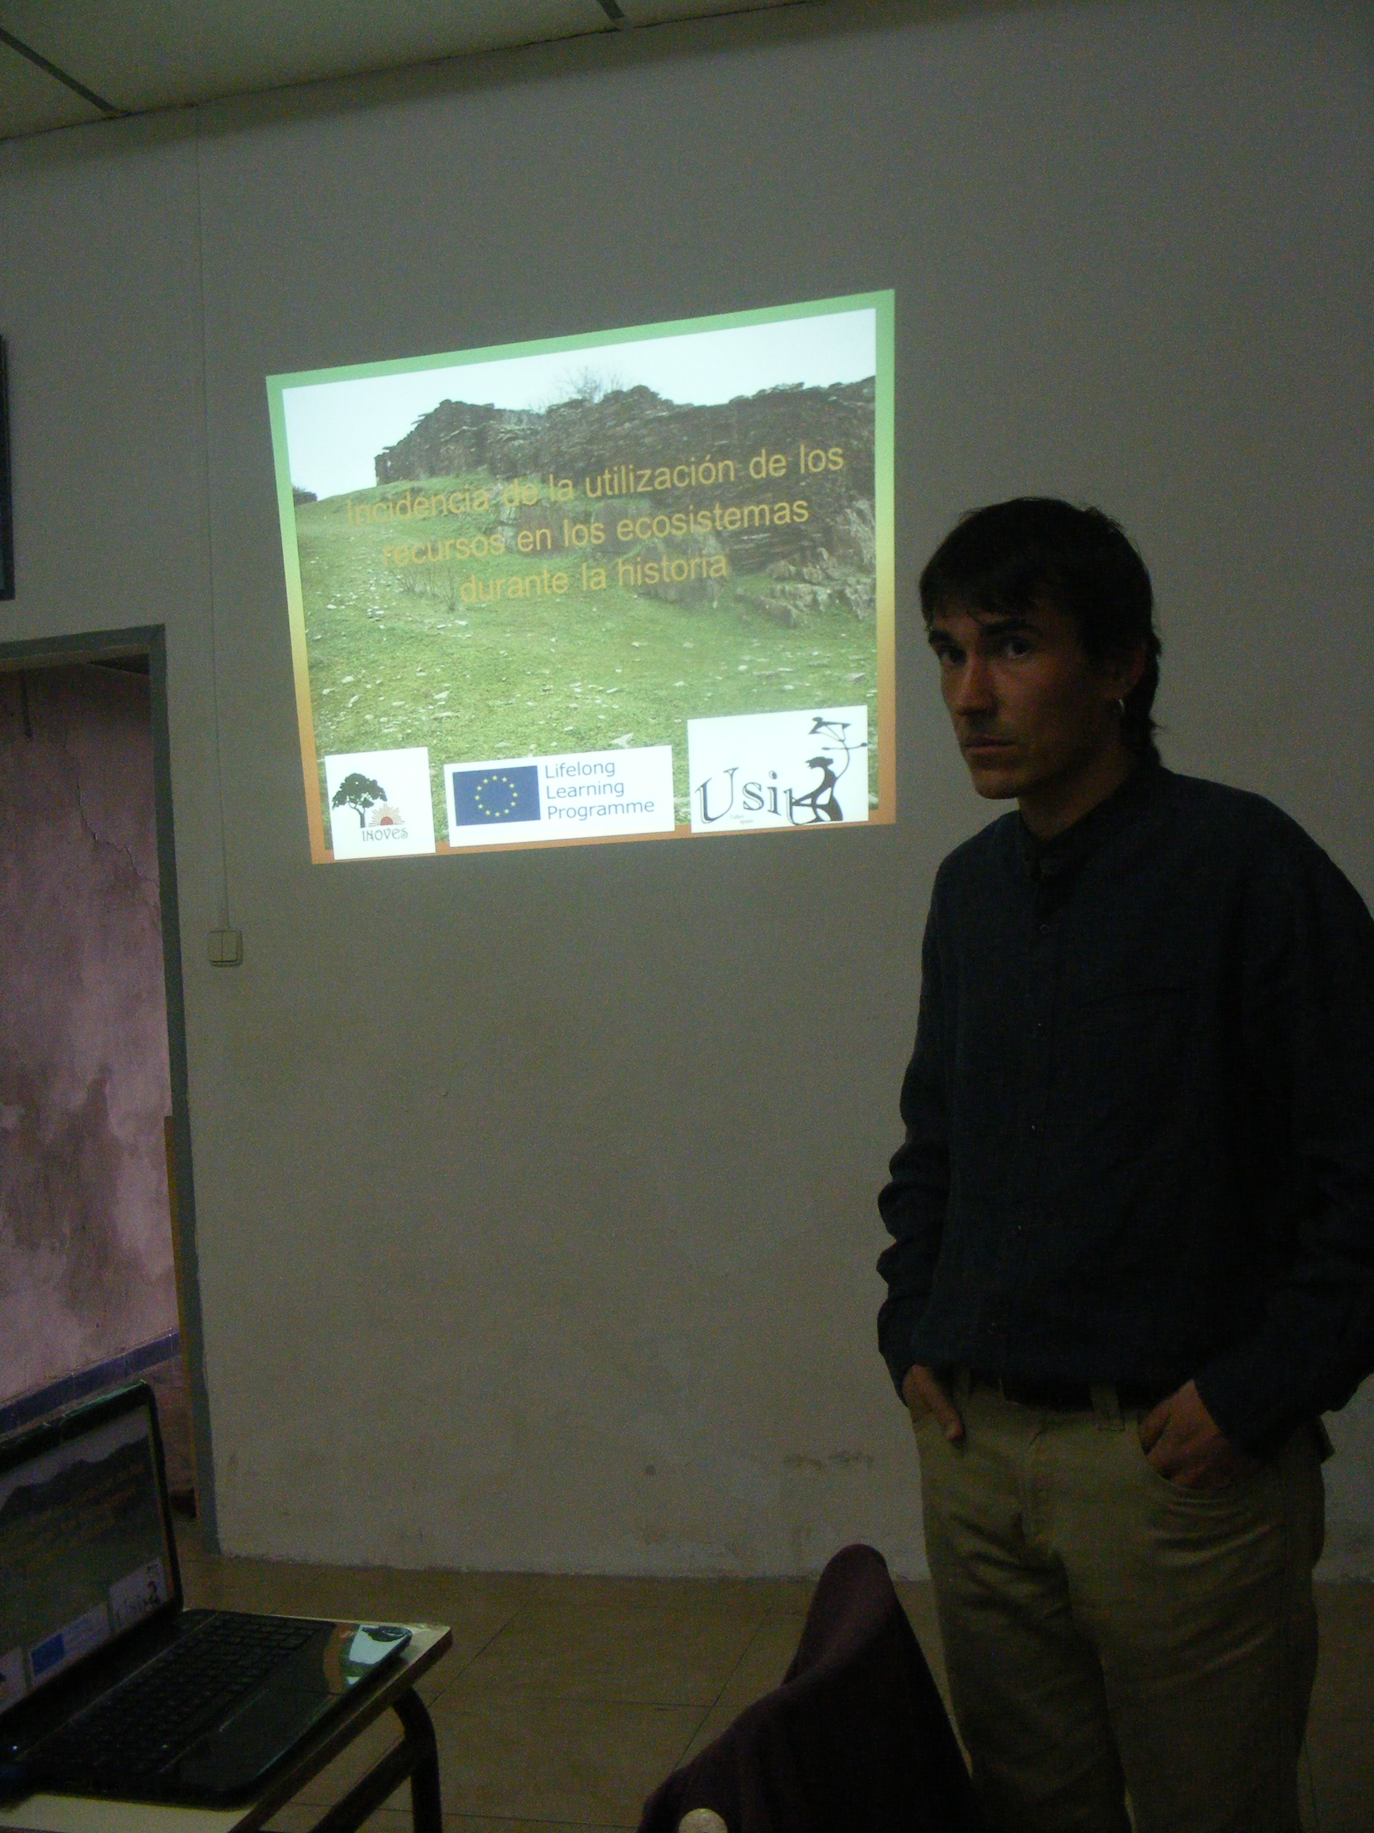The participants in the workshop were introduced to the Impact of use of resources on ecosystems throughout history, this is a very important aspect to all, as it has seen an evolution and a big change and now in these times we're realizing the damage we are doing to the planet and how we can colsve it that our chiñdren have a future.  
3 important parts were describe:  
where we come?   
where we are ?  
where we go ?  
After this introduction all participants deal with the question:   
Sustainable development is possible ??

The conclusions of the group were.

Sustainable development requires policy changes in many sectors and coherence between them. It entails balancing the economic, social and environmental objectives of society.

We all need to think globally and not just consider equations within our own ways of life.

We can help:

* Reducing our consumption of over-packaged products;
* Walking, bicycling or using public transit instead of car;
* Buying products that are certified fair-trade.
* Changing our living habits to include more sports and recreational activities so we will be in better physical condition.
* 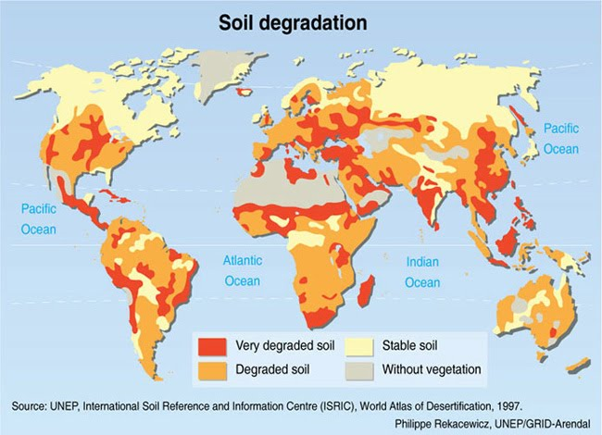Reducing, re-using and recycling!
* Buying Fair Trade!
* Buying locally sourced products!
* Using water wisely!
* Making healthy food choices!
* Being a good citizen!
* Turning off appliances when not in use!
* Considering renewable energy sources for home!

1.4 Efficient use of resources: Green energy, Water, Food and Social development.

In this talk were introduce 4 areas such as water, energy, social development and food, after that the participants have the opportunity to exchange their experiences and good practice in this areas.

Water: in this part was explain about the use of salt water, the importance of desalination, which are those that we have in the area and its functions, also the efficient use of irrigation water and the efficiency of human consumption, the importance of reusing the waste water.

Energy: in this part was explain about energy efficiency, what is and why is important, also an explanation on general consumption of energy in Spain and the important use in efficient way of sun, wind and movement.

Social development: in this part was explain about Efficient construction (bioclimatic) Efficient construction (biomaterials) , Efficient technologies , Efficient driving, Recycling

Food: in this part was explain about if the intensive farms are efficient? friendly food production, Eco Stamps warranty , Confidence in the producer.

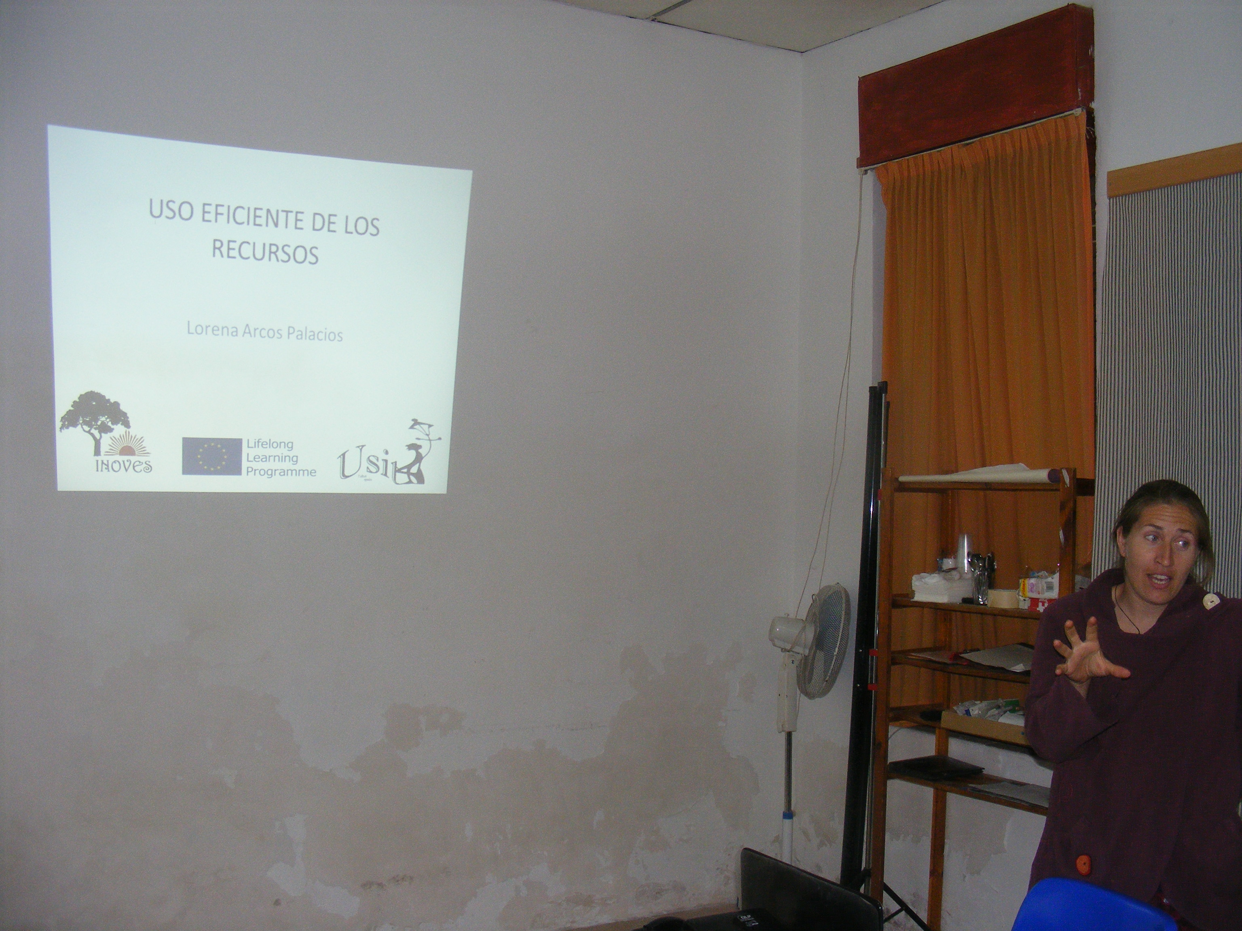

After the introduction of the 4 areas a small round table was created among the participants on the issues and reached the following conclusions :​

All the people agree that is possible to move towards a more efficient use of natural resources.

Recycling has become a practice with significant results for sectors such as paper, glass and resource extraction.

We need to educate and teach the new generation.

Also in important to think about:

* Save : Always that is possible take the opportunity to save resources.
* Recycle :Increasing recycling materials and reuse of components in the products.
* Replace :Replace the primary alternatives production resource that offer more efficient and have a lower environmental impact throughout its life cycle.
* Value :If we learn to value ecosystem services and natural resources, and assign a price, we will reduce the pressure on the environment.

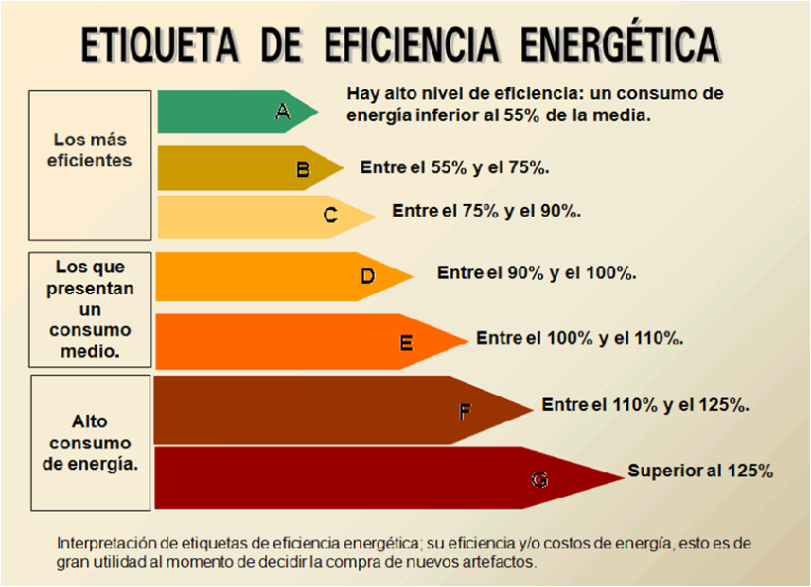

1.5 Ecogardens; The benefits

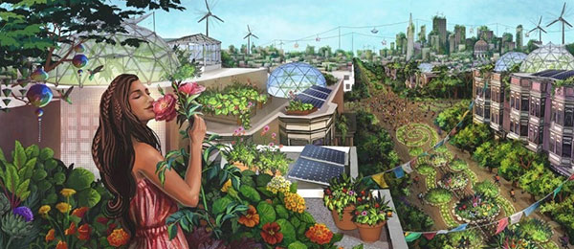In the last speech the theme of Ecogardens was introduce as a way to save natural resources and still enjoy gardens and landscapes.  Many methods of ecogardening are available.

During the speech were introduce different, ecogardening approaches:

* WaterWise Gardening, which uses plant choices to reduce water use, leaving more available for other uses such as agriculture, drinking water, and wildlife.
* Native Plant Gardening, which reduces chemical and water use and stimulates use of your garden by wildlife.
* Streamside Gardening techniques, using native plants to augment natural stream biology and function.
* Controlling invasive species of garden origin (An ecogardening concern).

After the introduction of the ecogardens approaches was explain to the participants the benefits of Eco-gardening to their life.

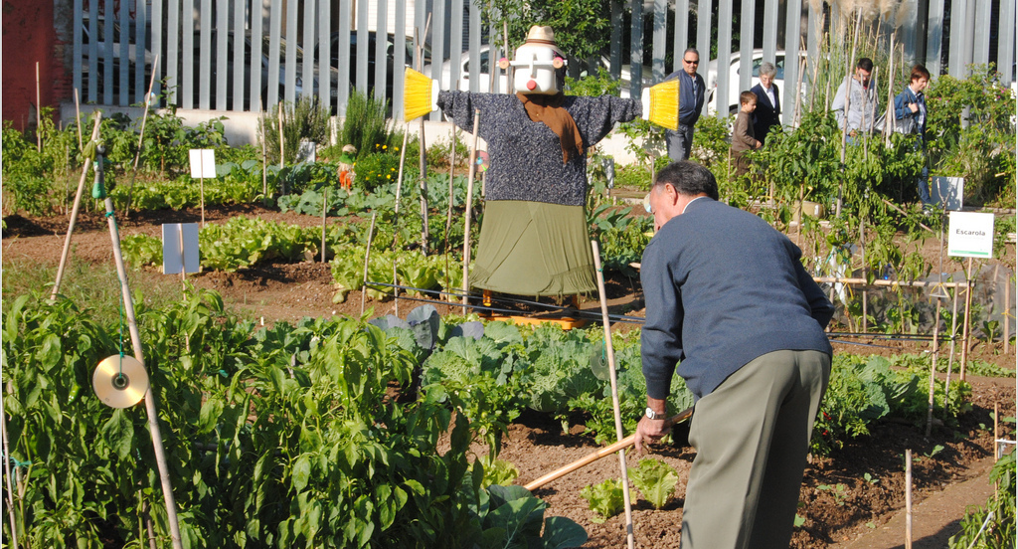And the most important benefits are:

* You’ll Enjoy Increased Nutritional Value
* You’ll Save Money
* You’ll Know Exactly What You’re Eating
* Your Attitude Will Change
* Your Food Will Taste Better
* You’ll Get Fresh Air and Exercise
* You’ll Build Your Knowledge
* It’s Fun!
* You’ll Promote Biodiversity
* You’ll Discover a New Approach to Life

1.6 Practical workshop: interactive dynamic (Ecological Food print)

After all the talks took place a little test to all participants so that they could also calculate their ecological food print, also to have a tool to use in their classes, with friends or family.   
This was important because many of the participants realized how amount of land and ocean area required to sustain their consumption patterns and absorb their wastes on an annual basis.

http://myfootprint.org/en/

1.7 Poster used for the Workshop:

